Introduction to Linux Services Understanding services in Linux: Systemd, init.d.Introduction to Apache and Nginx web servers.Practical (1 hour): Install Apache and start/stop services using systemctl. Task: Verify the web server is running by accessing it in a browser.

TASKS

1. Install the Apache web server on your Linux machine using the package manager (apt or yum), and confirm the installation by running the command to check its version.

ANS:

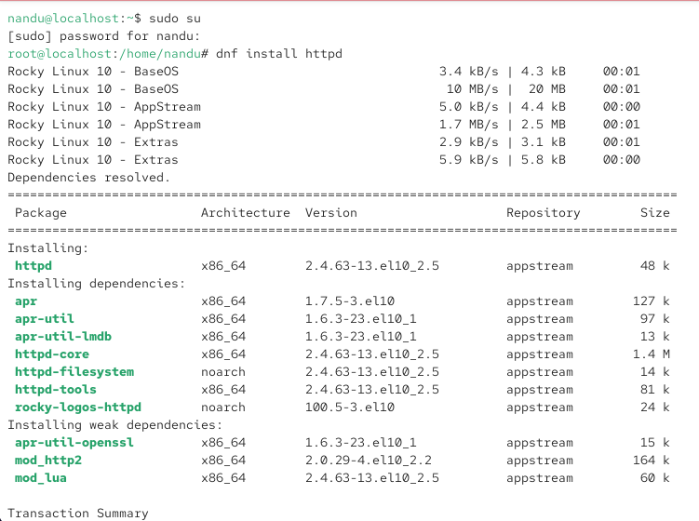

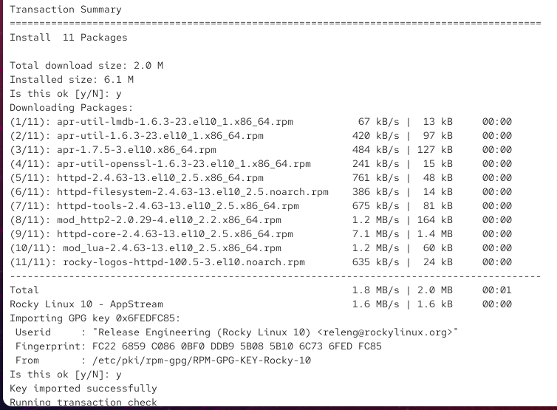

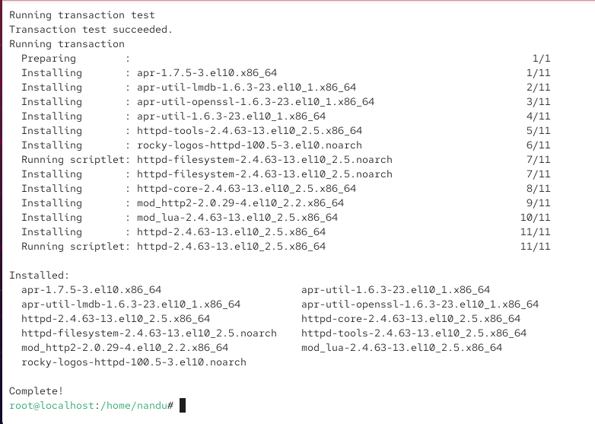

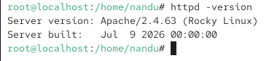

2. Start the Apache service using systemctl, then use systemctl status to verify it is running.

ANS:

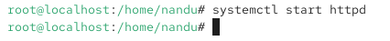

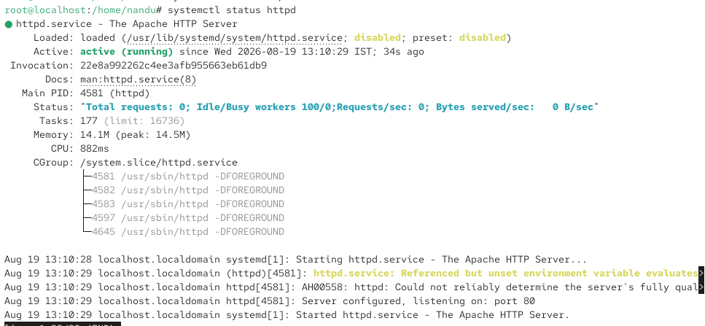

3. Stop and restart the Apache service using systemctl, and observe the difference between stop, start, and restart commands. Use 'systemctl stop apache2', 'systemctl start apache2', and 'systemctl restart apache2' (or 'httpd' on some systems).

ANS:

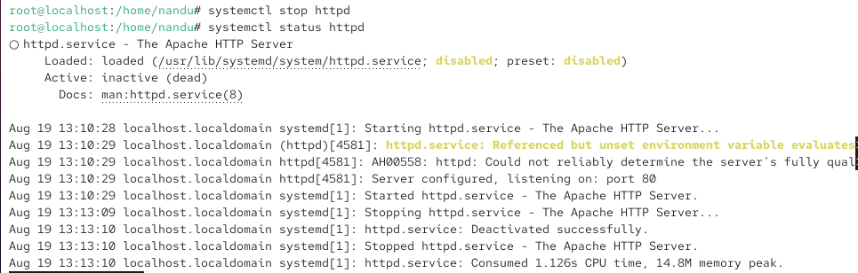

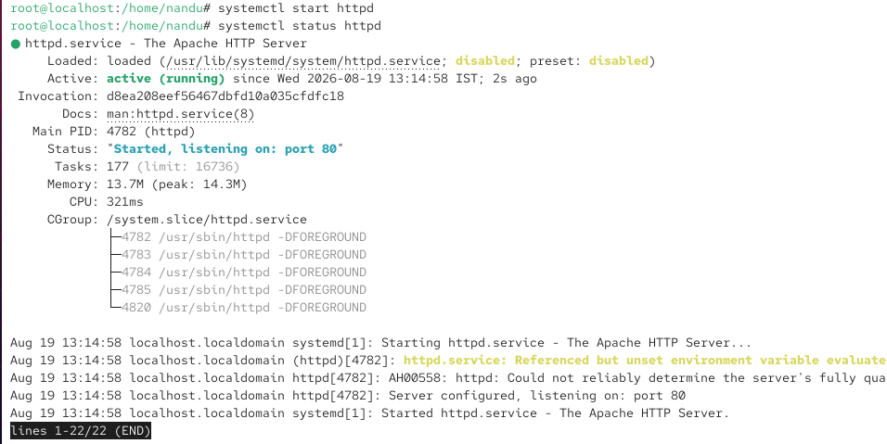

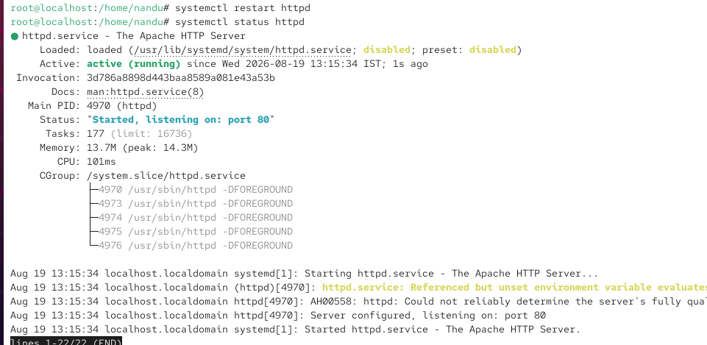

4. Open your browser and access http://localhost or your Linux machine's IP address to verify that the Apache default web page is displayed.

ANS:

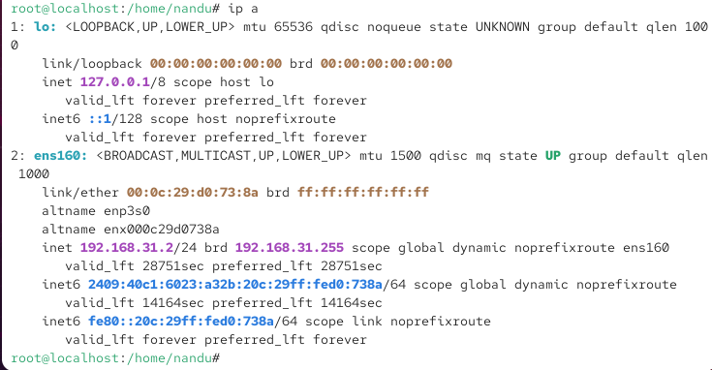

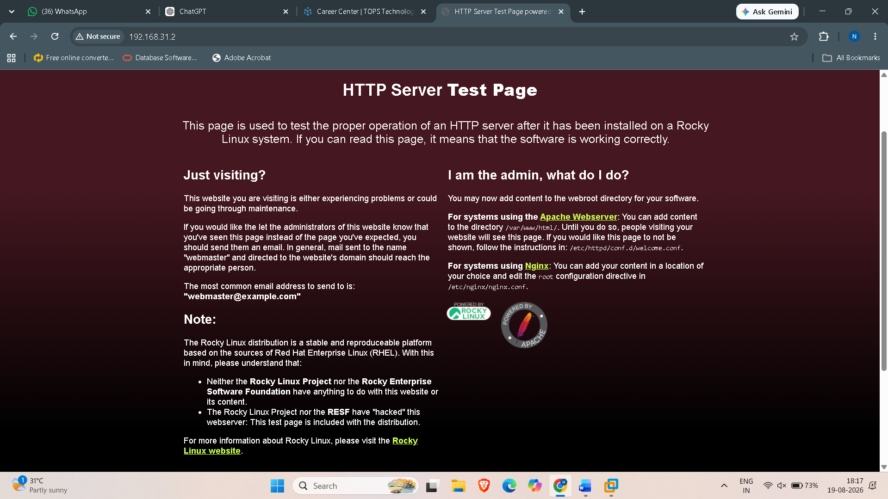

5. Write a short comparison (3-4 lines) between Apache and Nginx web servers, mentioning one key use-case for each based on your research.

ANS: Apache and Nginx are both popular web servers used to deliver websites and web applications.
Apache is highly modular and is commonly used for hosting multiple websites on one server through virtual hosts.
Nginx is lightweight and high-performance, and is commonly used as a reverse proxy or load balancer for application servers.
Overall, Apache is known for flexibility, while Nginx is often preferred for high-performance proxying and traffic management.

